TINY ML

1. **What do you understand by TinyML?**

TinyML, short for Tiny Machine Learning, refers to the practice of deploying machine learning models on extremely resource-constrained devices such as microcontrollers, embedded systems, and IoT devices. These devices typically have limited processing power, memory, and energy resources, making it challenging to run complex machine learning algorithms directly on them.

1. **What is difference between TinyML and ML?**

**The silly frog kissed ellie**

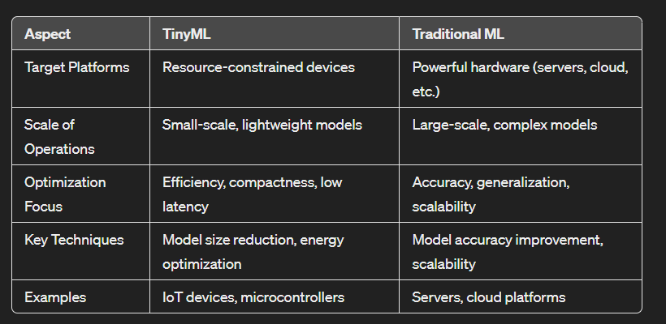

1. **Discuss the challenges Of low power ML applications.**

the challenges of low-power ML applications:

- *Resource Constraints****:*** devices having limited processing power, memory, and energy resources, makes it challenging to run complex machine learning algorithms directly on them.

- *Model Size*: Creating compact models without compromising accuracy is challenging due to restricted memory and storage capabilities.

1. **What are the advantages of TinyML? Why microcontrollers for TinyML, not CPU?**

**explain with suitable example.**

Advantages : PISS

1. *Low Power Consumption*: TinyML models are optimized for low power consumption, making them suitable for battery-powered devices and IoT applications.
2. *Real-Time Inference*: (inference- conclusion based on evidence & reasoning) TinyML enables real-time inference on edge devices, reducing latency and improving response times for critical applications.
3. *Privacy and Security*: Data processing and inference occur locally on the device, enhancing privacy and security by minimizing data transmission to external servers.
4. *Scalability*: TinyML models can be deployed across a large number of edge devices, providing scalability for distributed applications.

Why Microcontrollers for TinyML, Not CPUs:

1. *Resource Efficiency*: Microcontrollers are optimized for low power consumption, making them suitable for battery-powered devices and IoT applications.
2. *Cost-Effectiveness*: Microcontrollers are typically more cost-effective than CPUs, especially for mass deployment in IoT devices and embedded systems.
3. *Embedded Applications*: Microcontrollers are commonly used in embedded systems where space, power, and cost considerations are crucial, aligning well with the requirements of TinyML.

Example:

Consider a smart wearable device that monitors a person's heart rate and provides real-time alerts for irregularities. Using TinyML on a microcontroller, the device can run a lightweight machine learning model to analyze heart rate data locally. This enables immediate detection of anomalies without relying on continuous data transmission to a central server, thereby saving power, ensuring privacy, and reducing latency for critical health monitoring tasks.

1. **Briefly example a capstone project one can implement utilizing data science or TinyML.**

**Capstone Project: Smart Energy Management System**

- **Objective**: Develop a smart energy management system using data science or TinyML techniques to optimize energy usage in residential or commercial buildings.

**- Data Science Approach:**

- Use historical energy consumption data from sensors installed in buildings to analyze patterns, identify trends, and predict future energy demand.

- Implement machine learning algorithms such as regression, clustering, or time series forecasting to create models that optimize energy consumption based on factors like occupancy, weather conditions, and time of day.

- Develop a dashboard or application interface to visualize energy usage, provide insights, and suggest energy-saving strategies to users.

- **TinyML Approach:**

- Deploy TinyML models on microcontrollers integrated with energy monitoring sensors

- Train lightweight machine learning models to perform real-time analysis of energy data, detecting anomalies, predicting usage patterns, and optimizing energy allocation.

This capstone project combines data science or TinyML methodologies with energy management concepts to create a practical solution for optimizing energy usage, reducing costs, and promoting sustainability in buildings.

1. **How does TinyML contribute to the advancement of Internet of Things (IoT) applications compared to traditional machine learning approaches?**

TinyML contributes significantly to the advancement of Internet of Things (IoT) applications compared to traditional machine learning approaches in several ways:

1. **Resource Efficiency:**

- TinyML models are optimized for

* resource-constrained IoT devices,
* consuming less memory,
* processing power,
* and energy compared to traditional ML models.
* This efficiency enables IoT devices to perform complex machine learning tasks without overwhelming their limited hardware capabilities.

**2. Edge Computing:**

- TinyML facilitates edge computing by allowing machine learning models to run directly on IoT devices, reducing the need for constant data transmission to centralized servers.

**3. Privacy and Security:**

- By processing data locally on IoT devices, TinyML enhances privacy and security by reducing the amount of sensitive data sent over networks to external servers.

**4. Scalability:**

- TinyML models can be easily deployed across a large number of IoT devices, providing scalability for IoT applications.

**5. Cost-Effectiveness:**

- The efficiency and scalability of TinyML contribute to cost-effectiveness in IoT deployments. By reducing the computational and networking requirements, TinyML helps lower infrastructure costs and operational expenses.

1. **What are some common optimization techniques used in TinyML to achieve low latency and energy-efficient inference on resource-constrained devices?**

Several common optimization techniques are used in TinyML to achieve low latency and energy-efficient inference on resource-constrained devices. These techniques include:

**1. Quantization:**

- Quantization involves reducing the precision of numerical values in the model's parameters and activations. For example, converting 32-bit floating-point numbers to 8-bit integers reduces memory usage and computational complexity, leading to faster inference and lower energy consumption.

**2. Model Pruning:**

- Model pruning involves removing redundant or less important connections, nodes, or layers from the neural network model. This reduces the model's size.

**3. Model Compression:**

- Model compression techniques such as weight sharing, knowledge distillation, and matrix factorization reduce the size of the model without significantly compromising accuracy. This reduction in model size leads to faster inference and reduced memory usage, contributing to energy efficiency.

**4. Sparsity Techniques:**

- Sparsity techniques introduce sparsity in the model's parameters by setting certain weights or activations to zero. Sparse models require fewer computations during inference, resulting in lower latency and energy consumption.

**5. Hardware Acceleration:**

- Utilizing hardware accelerators such as dedicated neural network processing units (NNPUs), tensor processing units (TPUs), or custom integrated circuits (ICs) optimized for machine learning tasks can significantly improve inference speed and energy efficiency on resource-constrained devices.

1. **How do quantization and pruning techniques impact the size and performance of TinyML models? Provide examples to illustrate these effects.**

Quantization and pruning techniques play a crucial role in reducing the size and improving the performance of TinyML models. Let's delve into each technique and its impact with examples:

1. **Quantization**:

- *Impact on Size:* Quantization reduces the precision of numerical values in the model's parameters and activations. For instance, converting 32-bit floating-point numbers to 8-bit integers. This reduction in precision leads to smaller model sizes.

*- Impact on Performance*: While quantization reduces the model's size, it may slightly impact performance in terms of accuracy. However, modern quantization techniques, such as quantization-aware training (QAT) and post-training quantization, minimize this accuracy loss.

- *Example*: Consider a neural network used for image classification. After quantization, the model's parameters and activations are represented in lower precision (e.g., 8-bit integers), reducing the model size significantly. Despite the reduced precision, the quantized model maintains acceptable accuracy for tasks like object recognition on edge devices.

**2. Pruning**

- *Impact on Size*: pruning process reduces the model's size by removing redundant or less important connections, nodes, or layers from the neural network model.

- *Impact on Performance*: Pruning can improve performance by reducing overfitting, enhancing generalization, and speeding up inference.

- *Example*: Suppose we have a deep learning model for speech recognition deployed on a microcontroller. By applying pruning techniques, redundant connections and less important neurons are pruned, leading to a sparser and more efficient model. This pruned model achieves comparable accuracy to the original model while requiring fewer computational resources and memory, thus improving overall performance in TinyML applications.

1. **Discuss the role of transfer learning in TinyML applications. What are the benefits and challenges of transferring knowledge from pre-trained models to edge devices?**

Transfer learning plays a significant role in TinyML applications by leveraging knowledge from pre-trained models to improve the performance, efficiency, and effectiveness of machine learning models deployed on edge devices. Here's a discussion on the role, benefits, and challenges of transfer learning in TinyML:

**1. Role of Transfer Learning in TinyML:**

- Transfer learning involves transferring knowledge or features learned from a pre-trained model to a new, smaller model tailored for a specific task or domain.

- In TinyML applications, transfer learning helps overcome limitations such as limited training data, computational resources, and memory constraints by using pre-existing knowledge and features extracted from large-scale models.

**2. Benefits of Transfer Learning in TinyML:**

*- Improved Accuracy*: Transfer learning can improve the accuracy of TinyML models by transferring knowledge from pre-trained models.

*- Faster Training*: By starting with pre-trained weights or features, transfer learning reduces the training time required for TinyML models, making it more feasible to train models on resource-constrained edge devices.

*- Efficient Resource Utilization*: Transfer learning optimizes resource utilization by leveraging pre-existing knowledge.

**3. Challenges of Transferring Knowledge to Edge Devices:**

- *Model Compatibility:* Ensuring compatibility between pre-trained models and edge device architectures can be challenging, as edge devices often have limited hardware capabilities and may require model optimization or quantization.

- *Data Privacy:* Transferring pre-trained models to edge devices may raise concerns about data privacy and security, especially if the pre-trained models contain sensitive information .

- *Fine-Tuning*: Fine-tuning pre-trained models on edge devices requires careful optimization of hyperparameters, learning rates, and regularization techniques to prevent overfitting or underfitting.

- *Limited Training Data*: Edge devices may have limited access to labeled training data, which can affect the effectiveness of transfer learning, especially for tasks requiring domain-specific knowledge or nuances.

1. **Explain the importance of data preprocessing and feature engineering in TinyML projects. How can these steps improve model performance and robustness?**

Data preprocessing and feature engineering are crucial steps in TinyML projects as they directly impact model performance, efficiency, and robustness. Here's an explanation of their importance and how they improve model performance and robustness:

**1. Importance of Data Preprocessing:**

- *Data Cleaning*: Preprocessing involves cleaning and handling missing or erroneous data, ensuring data quality and reliability for model training.

- Normalization and Scaling: Normalizing and scaling input features help in bringing data into a consistent range, preventing features with larger scales from dominating the learning process.

- *Feature Extraction:* Preprocessing can involve feature extraction techniques to transform raw data into meaningful features that capture relevant information for the model.

*- Dimensionality Reduction*: Techniques like PCA (Principal Component Analysis) can reduce the dimensionality of the data, improving computational efficiency .

**2. Importance of Feature Engineering:**

- *Creating Relevant Features*: Feature engineering involves creating new features or modifying existing ones to capture domain knowledge and improve model understanding of the data.

- *Handling Categorical Data*: Feature engineering includes techniques like one-hot encoding or label encoding to represent categorical variables numerically, making them suitable for machine learning algorithms.

**3. Impact on Model Performance and Robustness:**

- *Improved Model Accuracy*: Proper data preprocessing and feature engineering can lead to cleaner, more informative data inputs, resulting in improved model accuracy.

- *Reduced Overfitting*: By preprocessing data to remove noise and irrelevant information and engineering meaningful features, models are less likely to overfit to the training data and generalize better to unseen data.

*- Enhanced Robustness*: Robust preprocessing and feature engineering techniques make models more resilient to variations and anomalies in the data, improving their robustness and reliability in real-world scenarios.

- *Efficient Learning*: Well-preprocessed and engineered features can simplify the learning task for the model, leading to faster convergence during training and more efficient use of computational resources in TinyML applications.

In summary, data preprocessing and feature engineering are essential steps in TinyML projects that enhance model performance, accuracy, and robustness by improving data quality, reducing noise, capturing relevant information, and simplifying the learning process for machine learning algorithms deployed on resource-constrained edge devices.

1. **What are some challenges developers face when deploying TinyML models on resource-constrained devices?**

Deploying TinyML models on resource-constrained devices presents several challenges for developers. Some of the key challenges include:

* 1. **Limited Processing Power:** Resource-constrained devices, such as microcontrollers and IoT devices, often have limited processing power. This can pose challenges in running complex machine learning algorithms efficiently and may require optimizations such as model quantization and pruning.
  2. **Memory Constraints**: Resource-constrained devices typically have limited memory, which can restrict the size of the model that can be deployed. Developers need to optimize models to minimize memory usage while maintaining acceptable performance.
  3. **Energy Consumption:** Energy efficiency is crucial for devices running on batteries or with limited power sources. TinyML models must be optimized to minimize energy consumption during inference, which may involve techniques like quantization, model compression, and efficient algorithm design.
  4. **Real-Time Processing**: Some applications require real-time processing and inference, which can be challenging on resource-constrained devices with limited computational capabilities. Developers must optimize models and algorithms to meet real-time performance requirements.
  5. **Testing and Validation:** Testing and validating TinyML models on resource-constrained devices can be challenging due to limited debugging tools and testing environments. Developers need robust testing strategies to ensure model accuracy, reliability, and robustness in real-world scenarios.

1. **Can you give an example of a real-world application where TinyML can be implemented effectively?**

One example of a real-world application where TinyML can be implemented effectively is in predictive maintenance for industrial equipment. Predictive maintenance involves using data from sensors and machinery to predict equipment failures or malfunctions before they occur, allowing for proactive maintenance and minimizing downtime.

Here's how TinyML can be applied effectively in predictive maintenance:

1. **Data Collection**: Install sensors on industrial equipment to collect data such as temperature, vibration, pressure, and other relevant parameters. This data is continuously monitored and logged over time.

2. **Data Preprocessing:** Preprocess the sensor data by cleaning, filtering, normalizing, and aggregating it to ensure data quality and consistency. Feature engineering techniques may also be applied to extract relevant features from the raw sensor data.

3. **Model Development**: Develop TinyML models, such as machine learning classifiers or anomaly detection algorithms, using the preprocessed sensor data. These models can predict equipment failures, detect anomalies in performance, or classify different operating conditions.

4. **Deployment on Edge Devices:** Deploy the TinyML models on edge devices or microcontrollers embedded within the industrial equipment. The models can run locally on these devices, performing real-time inference and analysis without relying on continuous data transmission to external servers.

5. **Proactive Maintenance:** Based on the predictions and alerts generated by the TinyML models, maintenance teams can take proactive actions such as scheduling preventive maintenance, replacing worn-out components, or adjusting equipment settings to prevent failures and minimize downtime.

This application of TinyML in predictive maintenance offers several benefits, including:

- Cost Savings

- Improved Equipment Reliability

- Enhanced Safety

**R**

1. **Explain the statistical and Programming features of R/Python programming language?**

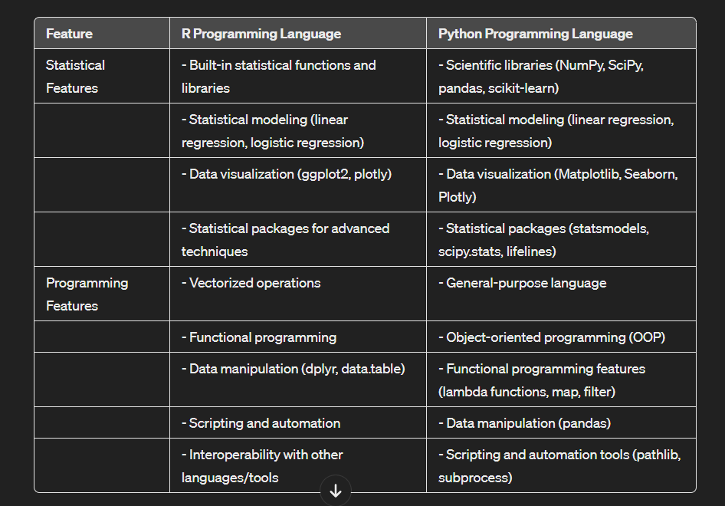

1. **explain various data structures or packages used in R/Python?**

That said, let's briefly discuss some common data structures and packages used in R:

1. Data Structures in R:

- **Vectors**: Used for storing homogeneous data types like numeric, character, or logical values.

- **Lists**: Flexible data structures that can store heterogeneous elements and other data structures.

- **Data Frames**: Two-dimensional structures for storing tabular data with rows and columns, similar to a spreadsheet.

- **Matrices and Arrays**: Multi-dimensional structures for handling numerical data.

2. Packages in R:

- **dplyr**: For data manipulation tasks like filtering, sorting, grouping, and summarizing data frames.

- **ggplot2**: A powerful package for creating visually appealing and customizable plots and graphs.

- **dygraphs**: Creates interactive time series plots with zooming and panning capabilities.

- **leaflet**: Generates interactive maps with markers, polygons, and custom overlays using Leaflet JavaScript library.

3. **Briefly explain a capstone project on can develop for data visualization and analytics.**

Certainly! Here's a brief outline of a Capstone Project focused on data visualization and analytics:

Project Title: Financial Performance Dashboard for a Retail Company

Project Objective:

Develop an interactive data visualization dashboard to analyze and monitor the financial performance of a retail company. The dashboard should provide actionable insights to support strategic decision-making and improve business outcomes.

Key Components and Features:

1. Data Collection and Integration:

- Gather financial data from multiple sources including sales transactions, expenses, inventory, and profit margins.

- Integrate and clean the data to ensure consistency and accuracy for analysis.

2. Dashboard Design:

- Design a user-friendly and visually appealing dashboard layout using a tool like Power BI or Tableau.

- Include key performance indicators (KPIs) such as revenue trends, gross margins, sales by product category, expenses breakdown, and profitability ratios.

3. Data Visualization:

- Utilize various visualization types such as line charts, bar charts, pie charts, and scatter plots to represent different aspects of financial performance.

- Create interactive elements like filters, slicers, and drill-down options to enable users to explore data at different levels of detail.

4. Financial Analysis:

- Conduct trend analysis to visualize revenue growth or decline over time, identify seasonal patterns, and assess the impact of marketing campaigns or promotions.

- Compare sales performance across different product categories, regions, or store locations to identify top-performing segments and areas for improvement.

5. Profitability Analysis:

- Calculate and visualize gross margins, net profits, and profit margins to evaluate the company's overall profitability and cost-effectiveness.

- Use trend lines and forecasting models to predict future revenue and profitability based on historical data trends.

6. Expense Management:

- Visualize expenses by category (e.g., marketing, operations, payroll) and track expense trends over time.

- Identify cost-saving opportunities, detect outliers or anomalies in spending, and optimize resource allocation.

7. Interactive Features:

- Implement interactive elements such as hover-over tooltips, click-to-filter options, and dynamic data updates for real-time analysis.

- Enable users to customize views, save preferences, and export insights for further analysis or reporting.

8. Presentation and Documentation:

- Prepare a comprehensive documentation outlining the data sources, data preparation steps, dashboard design principles, and analytical insights.

- Present the dashboard and findings to stakeholders, highlighting key insights, actionable recommendations, and the value of data-driven decision-making.

By completing this Capstone Project, you'll demonstrate proficiency in data collection, cleaning, visualization, and analysis techniques, as well as the ability to create impactful data-driven solutions for business stakeholders.

1. **How is distributed database processed using AI?**

Distributed databases can benefit significantly from artificial intelligence (AI) techniques in various ways.

1. Query Optimization: AI-based query optimization involves using machine learning algorithms to analyze historical query execution data and database structure to generate optimal query plans.

2. Automated Database Tuning: AI can automate the tuning of database parameters in distributed databases. Automated tuning using AI techniques reduces manual intervention.

3. Predictive Analytics for Resource Allocation: AI-driven predictive analytics can forecast workload trends, data access patterns, and resource needs in distributed databases.

4. Anomaly Detection and Performance Monitoring: AI-powered anomaly detection techniques can monitor distributed database operations, identify abnormal behaviors, and detect potential performance issues or security threats. It enhances system reliability, data integrity, and security in distributed database environments

1. **Briefly explain a capstone-project on can develop utilizing R/Python programming language**

A capstone project using R or Python programming language can be developed in various domains, but let's consider a specific example in the field of healthcare analytics. Here's a brief explanation of a healthcare analytics capstone project:

**Title: Predictive Modeling for Hospital Readmissions**

Objective: The objective of this capstone project is to develop a predictive model using R or Python to identify patients at high risk of hospital readmissions within 30 days of discharge. The project aims to improve healthcare outcomes, reduce readmission rates, and optimize resource allocation in hospitals.

**Project Components:**

1. **Data Collection**: Gather electronic health records (EHR) data from a healthcare dataset containing patient demographics, medical history, diagnosis codes, medications, procedures, laboratory results, and discharge information.

2. **Data Preprocessing**: Preprocess the collected data using R or Python to clean, handle missing values, normalize numerical features, encode categorical variables, and perform feature engineering.

3. **Exploratory Data Analysis (EDA):** Conduct EDA using data visualization libraries in R (ggplot2) or Python (matplotlib, seaborn) to gain insights into the dataset, identify patterns, correlations, and potential predictive features related to hospital readmissions.

4. **Feature Selection:** Apply feature selection techniques (e.g., recursive feature elimination, feature importance ranking) to select the most relevant features for building the predictive model.

5. **Model Development:** Build predictive models using machine learning algorithms such as logistic regression, random forests, or gradient boosting classifiers in R (with packages like caret, glmnet) or Python (scikit-learn, XGBoost).

6. **Model Evaluation:** Evaluate the performance of the predictive models using appropriate metrics such as accuracy, precision, recall, F1 score, and area under the receiver operating characteristic curve (AUC-ROC).

7. **Model Optimization**: Fine-tune hyperparameters, perform cross-validation, and handle class imbalance (if present) to optimize the predictive models for better generalization and performance.

8. **Deployment**: Deploy the optimized predictive model as a web application or API using frameworks like Shiny (R) or Flask/Django (Python) to enable real-time predictions on new patient data.

9. **Validation and Testing**: Validate the deployed model using a separate validation dataset or through real-time testing with new patient data. Monitor model performance and recalibrate as needed.

10. **Documentation and Presentation**: Prepare comprehensive documentation detailing the project methodology, data preprocessing steps, model development process, evaluation results, insights gained, and recommendations. Present the findings, challenges, and outcomes of the capstone project in a final presentation.

This healthcare analytics capstone project using R or Python programming language showcases skills in data preprocessing, exploratory data analysis, machine learning modeling, model evaluation, deployment, and communication of findings, making it a valuable and impactful project in the healthcare domain.

1. **What are the-common goals of statistical modelling? Explain various characteristics of processed data?**

The common goals of statistical modeling include:

1. **Prediction**: Statistical models are often used to predict future outcomes based on historical data. This can be applied in various fields such as finance, healthcare, marketing, and weather forecasting.
2. **Explanatory Modeling:** Statistical models are used to explain the relationships between variables and understand the impact of independent variables on dependent variables.
3. **Classification and Clustering**: Statistical models are employed for classification tasks and clustering tasks
4. **Model Comparison and Selection:** Statistical modeling involves comparing different models, selecting the most appropriate model based on criteria like goodness of fit, accuracy, simplicity, and interpretability.

As for the characteristics of processed data, here are various aspects to consider:

1. **Data Quality:** Processed data should be of high quality, free from errors, outliers, and missing values. Data cleaning and validation techniques are used to ensure data quality.

2. **Accuracy**: Processed data should accurately represent the real-world phenomena or variables being measured.

3. **Relevance**: Processed data should contain relevant information that is useful for the intended analysis or modeling task. Irrelevant or redundant data can lead to model complexity and inefficiency.

4. **Consistency**: Processed data should be consistent across different sources, time periods, or data points.

5. **Completeness**: Processed data should be complete, with all necessary variables and information included. Missing data can lead to biased analyses and inaccurate conclusions.

1. **Difference between R and python**

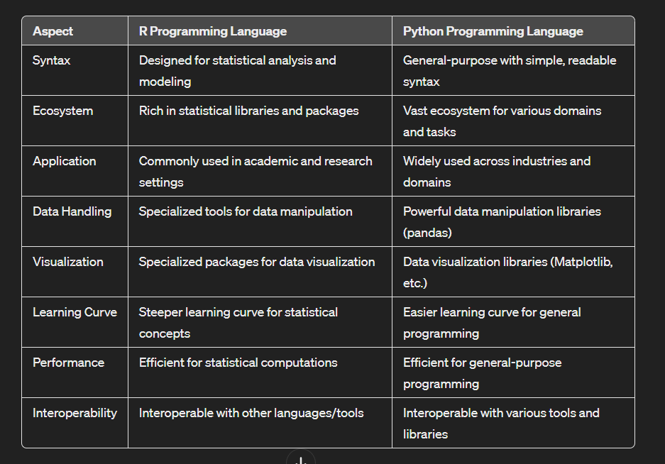

DATA VISUALISATION

1. **What is data visualization? Why is it important in business? What is its advantage?**

Data visualization refers to the graphical representation of data and information. It involves the use of charts, graphs, maps, and other visual elements to present complex data sets in a clear, concise, and understandable format.

Data visualization is crucial in business for several reasons:

**- Enhanced Decision Making**: Visualizing data helps business leaders and decision-makers quickly grasp insights and trends, enabling informed decision-making.

- **Communication**: Visual representations make it easier to communicate complex data and findings to stakeholders, clients, and team members, fostering better understanding and collaboration.

- **Identifying Patterns and Trends:** Visualization tools allow businesses to identify patterns, trends, correlations, and outliers within large datasets, leading to actionable insights.

- **Monitoring Performance**: By visualizing key performance indicators (KPIs) and metrics, businesses can monitor their performance in real-time and make timely adjustments as needed.

3. What is its advantage?

The advantages of data visualization in business include:

**- Clarity and Understanding**: Visual representations simplify complex data, making it easier for stakeholders to understand and interpret information.

- **Efficient Analysis**: Visualization tools enable rapid analysis of data, allowing businesses to identify trends, patterns, and outliers more efficiently.

- **Decision Support**: Data visualization provides decision-makers with actionable insights and supports evidence-based decision-making processes.

- **Communication**: Visualizations facilitate clear and effective communication of data insights to diverse audiences, promoting collaboration and alignment.

- **Strategic Planning**: By visualizing data related to market trends, customer behavior, and performance metrics, businesses can develop informed strategies and plans for growth and improvement.

1. **what is Power BI ? How Power BI helps in providing an effective solution for businesses?**

Power BI is a business intelligence and data visualization tool developed by Microsoft. It allows users to connect to various data sources, and share insights across an organization. Power BI encompasses a suite of tools including Power BI Desktop (for report authoring), Power BI Service (for cloud-based sharing and collaboration), and Power BI Mobile (for accessing reports on mobile devices).

Power BI provides several benefits and features that make it an effective solution for businesses:

- **Data Integration**: Power BI can connect to a wide range of data sources, including databases, cloud services, Excel files, and streaming data sources. This allows businesses to consolidate and integrate data from multiple sources for comprehensive analysis.

- **Data Preparation**: Power BI offers robust data preparation capabilities, allowing users to transform, clean, and shape data using intuitive graphical tools. This helps in preparing data for analysis and visualization without the need for complex coding.

- **Interactive Visualizations**: Power BI enables users to create interactive and visually appealing dashboards, reports, and charts. Users can customize visualizations, apply filters, drill down into data, and create dynamic insights that aid in decision-making.

- **AI and Machine Learning Integration**: Power BI integrates with Azure AI and machine learning services, allowing businesses to leverage advanced analytics capabilities such as predictive modeling, anomaly detection, and natural language processing within their reports and dashboards.

- **Collaboration and Sharing**: Power BI Service enables users to publish and share reports securely across teams and departments. It supports collaboration features like commenting, sharing permissions, and real-time data updates, fostering collaboration and knowledge sharing.

1. **Briefly explain a Capstone Project one can develop using Power BI for data visualization and analytics.**

A Capstone Project using Power BI for data visualization and analytics could involve creating a comprehensive business intelligence dashboard for a fictional company. Here's an outline of such a project:

1. Data Collection and Preparation:

- Identify the data sources required for the project, such as sales data, customer data, inventory data, etc.

- Collect and integrate the data into a unified dataset suitable for analysis.

- Perform data cleaning, transformation, and aggregation as needed to ensure data quality and compatibility.

2. Dashboard Design:

- Define the key performance indicators (KPIs) and metrics that are relevant to the business objectives.

- Design the layout and structure of the Power BI dashboard, including visualizations such as charts, graphs, tables, and maps.

- Create interactive elements like slicers, filters, and drill-throughs to enhance user interactivity and exploration.

3. Data Visualization:

- Use Power BI's visualization capabilities to create insightful charts and graphs for different aspects of the business, such as sales trends, customer demographics, product performance, and geographical distribution.

- Incorporate advanced visualizations like geographic maps, trend lines, Pareto charts, and custom visuals to convey complex insights effectively.

4. Analytics and Insights:

- Apply analytics techniques within Power BI to derive meaningful insights from the data.

- Perform trend analysis, correlation analysis, segmentation, and other analytical methods to uncover patterns, relationships, and opportunities.

- Use features like DAX (Data Analysis Expressions) for calculations, measures, and advanced data manipulation.

5. Interactive Features:

- Implement interactive features that allow users to drill down into data, filter results based on criteria, and explore different perspectives.

- Enable dynamic updating of visualizations in response to user interactions or changes in underlying data.

6. Dashboard Deployment and Sharing:

- Publish the Power BI dashboard to the Power BI service for online access.

- Configure access permissions and sharing settings to collaborate with stakeholders and team members.

- Schedule data refreshes and updates to ensure the dashboard reflects the latest information.

7. Documentation and Presentation:

- Document the data sources, data preparation steps, dashboard design principles, and analytical insights.

- Prepare a presentation or report summarizing the project objectives, methodology, findings, and recommendations.

- Present the dashboard and insights to stakeholders, highlighting the value of using Power BI for data visualization and analytics.

This Capstone Project would showcase your ability to collect, analyze, and visualize data effectively using Power BI, providing actionable insights for decision-making and business improvement.

1. **how is distributed database processed using ai? how can you acheive machine learning in spark?**

Distributed databases and AI can be integrated in several ways to enhance data processing, analysis, and decision-making. Here are some ways this integration can happen:

1. AI for Distributed Database Management:

- Query Optimization: AI techniques like reinforcement learning can be used to optimize query execution plans in distributed databases. These algorithms can learn from historical query performance data and adaptively improve query processing efficiency.

- Automated Tuning: AI-driven tools can automatically tune database parameters and configurations in distributed environments. This includes adjusting resource allocation, storage strategies, indexing, and caching mechanisms based on workload patterns and performance goals.

- Anomaly Detection: AI models can monitor distributed database operations to detect anomalies, performance bottlenecks, or security threats. This proactive monitoring helps in identifying and resolving issues before they impact system performance or data integrity.

2. Machine Learning in Spark:

Apache Spark is a popular distributed computing framework that supports machine learning through its MLlib library. Here's how you can achieve machine learning in Spark:

- Data Preparation: Use Spark's DataFrame API to load, clean, and transform data for machine learning tasks. Spark provides efficient parallel processing capabilities for data preparation tasks.

- Algorithm Implementation: Spark MLlib offers a wide range of machine learning algorithms such as regression, classification, clustering, and collaborative filtering. You can leverage these algorithms directly or develop custom algorithms using Spark's distributed computing capabilities.

- Model Training: Utilize Spark's distributed computing model to train machine learning models on large datasets. Spark MLlib supports distributed training for many algorithms, enabling scalable model training across clusters of machines.

- Model Evaluation and Deployment: Evaluate trained models using cross-validation, metrics, and validation techniques available in Spark MLlib. Once you have a satisfactory model, deploy it for real-time predictions or batch processing within Spark applications.

By combining distributed database management techniques with AI-driven optimizations and integrating machine learning capabilities into distributed computing frameworks like Spark, organizations can achieve scalable, efficient, and intelligent data processing and analytics solutions.

1. **How does data visualization enhance data-driven decision-making in businesses? Provide examples of visualizations that are commonly used for this purpose.**

1. **Clarity and Understanding**: Data visualization presents complex data in a visual format that is easy to understand and interpret, enabling stakeholders to grasp key insights quickly.

2. **Identifying Trends and Patterns**: Visualizations help businesses identify trends, patterns, correlations, and outliers within large datasets, allowing for more informed decision-making based on data-driven insights.

3. **Comparative Analysis**: Visualizations facilitate comparative analysis by visually comparing different data points, metrics, or performance indicators, aiding in benchmarking and performance evaluation.

Examples of Visualizations commonly used for Data-Driven Decision-Making:

1. **Line Charts**: Line charts are effective for showing trends over time, such as sales trends, revenue growth, or stock price fluctuations.



1. **Bar Charts and Column Charts**: Bar and column charts are used to compare categorical data or display rankings, such as market share by product category or sales performance by region.



1. **Pie Charts and Donut Charts**: Pie and donut charts are useful for illustrating proportions and percentages, such as market segmentation or budget allocations.

 

1. **Scatter Plots**: Scatter plots are used to visualize relationships between variables, such as correlation between marketing spend and sales revenue or customer satisfaction scores versus product ratings.

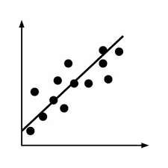

5. **Heatmaps**: Heatmaps display data using colors to represent values, making it effective for visualizing patterns, density, or concentrations within datasets, such as website traffic heatmaps or risk assessment heatmaps.

6. **Dashboard Widgets**: Dashboards combine multiple visualizations (e.g., charts, graphs, KPI widgets) into a single interactive interface, providing a comprehensive overview of key metrics and performance indicators for informed decision-making.

7. **Geospatial Maps**: Geospatial maps visualize data based on geographical locations, allowing businesses to analyze regional trends, market penetration, customer distribution, and logistical considerations.

By leveraging these and other visualization techniques, businesses can enhance data-driven decision-making by making data more accessible, understandable, and actionable for stakeholders at all levels of the organization.

1. **What are the key considerations when designing interactive dashboards for data visualization projects?**

Designing interactive dashboards for data visualization projects requires careful consideration of several key factors to ensure effectiveness, usability, and meaningful insights. Here are the key considerations:

1. **Know Your Audience**: Understand the needs, preferences, and expertise levels of your target audience to design dashboards that resonate with them and provide relevant insights.

2. **Define Objectives and KPIs**: Clearly define the objectives of the dashboard and identify key performance indicators (KPIs) that stakeholders need to monitor and analyze.

3. **Choose the Right Visualizations**: Select appropriate visualizations (e.g., charts, graphs, maps) based on the type of data and the insights you want to convey. Use a mix of visual elements to provide a comprehensive view.

4. **Provide Context and Annotations**: Add contextual information, explanations, and annotations to guide users and provide additional insights into the data displayed on the dashboard.

By considering these key factors when designing interactive dashboards for data visualization projects, you can create dashboards that effectively communicate insights, empower decision-making, and deliver value to stakeholders.

1. **Compare and contrast static and dynamic visualizations in terms of their utility and when each type is preferable.**

**Static Visualizations**: Static visualizations are pre-generated images or graphics that do not change based on user interactions. They are typically used to present a snapshot of data at a specific point in time.

Preferable When:

- The data does not require frequent updates.

- The goal is to provide a fixed representation of data for reference or reporting purposes.

- Users do not need to interact with or explore the data dynamically.

**Dynamic Visualizations**: Dynamic visualizations are interactive and allow users to explore and interact with data in real-time. They can update, filter, drill down, and change based on user inputs or interactions.

Preferable When:

- Users need to analyze and explore data interactively.

- The data is continuously updated, and users require real-time insights.

- Users need to customize views, apply filters, or drill down into specific details.

SPARK

1. **What is Regularization and what kind of problems does regularization solve?**

Regularization is a technique used in machine learning and statistical modeling to prevent overfitting and improve the generalization ability of a model. Overfitting occurs when a model learns the training data too well, capturing noise and irrelevant patterns that do not generalize to new, unseen data. Regularization helps in controlling the complexity of a model and reducing the risk of overfitting by adding a penalty term to the model's objective function.

There are two main types of regularization commonly used in machine learning:

1. L1 Regularization (Lasso Regularization): L1 regularization adds a penalty term to the model's objective function that is proportional to the absolute values of the model's coefficients. It encourages sparsity in the model by shrinking some coefficients to exactly zero, effectively performing feature selection and reducing the model's complexity.

Problems Solved by L1 Regularization:

- Feature Selection: L1 regularization helps in selecting relevant features by shrinking irrelevant features' coefficients to zero, effectively eliminating them from the model.

- Avoiding Overfitting: By reducing the number of features and controlling model complexity, L1 regularization prevents overfitting and improves generalization performance.

2. L2 Regularization (Ridge Regularization): L2 regularization adds a penalty term to the model's objective function that is proportional to the squared magnitudes of the model's coefficients. It penalizes large coefficients but does not force them to zero, leading to more stable and robust models compared to L1 regularization.

Problems Solved by L2 Regularization:

- Overfitting Prevention: L2 regularization helps in preventing overfitting by penalizing large coefficients and reducing the model's sensitivity to noise and outliers in the training data.

- Improved Generalization: By controlling model complexity and reducing the risk of overfitting, L2 regularization improves the model's ability to generalize well to new, unseen data.

1. **Briefly explain a capstone project one can develop using distributed databases.**

A capstone project involving distributed databases can focus on developing a scalable and efficient data management system for a specific domain or industry. Here's a brief overview of a capstone project idea related to distributed databases:

Title: Scalable E-commerce Analytics Platform using Distributed Databases

Objective: The objective of this capstone project is to design and implement a scalable analytics platform for an e-commerce company that can handle large volumes of data, provide real-time insights, and support complex analytical queries.

Key Components and Features:

1. Data Ingestion: Develop a data ingestion pipeline to collect and process data from various sources such as website interactions, sales transactions, customer reviews, and inventory updates. Utilize distributed databases to store and manage the ingested data efficiently.

2. Distributed Database Architecture: Design a distributed database architecture using technologies such as Apache Cassandra, Apache HBase, or Google Bigtable. Distribute data across multiple nodes to ensure scalability, fault tolerance, and high availability.

3. Data Modeling: Create optimized data models for storing different types of e-commerce data, including user profiles, product catalogs, orders, payments, shipping information, and customer feedback. Use techniques like denormalization, partitioning, and indexing to optimize query performance.

4. Real-time Analytics: Implement real-time analytics capabilities to monitor key e-commerce metrics such as website traffic, sales performance, customer behavior, and product popularity. Use stream processing frameworks like Apache Kafka or Apache Flink for real-time data processing.

5. Interactive Dashboards: Develop interactive dashboards and visualizations using tools like Apache Superset, Tableau, or Power BI. Provide stakeholders with intuitive dashboards to explore sales trends, customer segmentation, conversion rates, and inventory management insights.

1. Machine Learning Integration: Integrate machine learning algorithms for predictive analytics, recommendation systems, fraud detection, and customer segmentation. Use distributed machine learning frameworks such as Apache Spark MLlib or TensorFlow on distributed data.
2. **which tools Spark's Machine Leaming library (MLIib) provide? highlight the basic features/uses.**

Spark's Machine Learning library (MLlib) provides a wide range of tools and algorithms for machine learning tasks on distributed data processing frameworks like Apache Spark. Here are some of the key tools and basic features offered by Spark's MLlib:

1. Classification Algorithms:

- Logistic Regression: Used for binary classification tasks.

- Decision Trees: Effective for both classification and regression tasks.

- Random Forest: Ensemble method for classification and regression.

- Gradient-Boosted Trees (GBT): Boosting algorithm for classification and regression.

2. Regression Algorithms:

- Linear Regression: Used for linear regression tasks.

- Generalized Linear Models (GLM): Flexible models for regression tasks.

3. Clustering Algorithms:

- K-Means: Used for clustering and unsupervised learning.

- Bisecting K-Means: Hierarchical clustering algorithm.

- Gaussian Mixture Model (GMM): Clustering with Gaussian distributions.

4. Collaborative Filtering:

- Alternating Least Squares (ALS): Used for collaborative filtering and recommendation systems.

5. Dimensionality Reduction:

- Principal Component Analysis (PCA): Used for dimensionality reduction.

- Singular Value Decomposition (SVD): Matrix factorization technique for recommendation systems.

1. **breifly explain a Capstone Project one can develop using Apache SparK on distrubuted databases**

Capstone Project Idea Using Apache Spark on Distributed Databases:

Title: Real-time Fraud Detection System for Financial Transactions

Objective: The objective of this capstone project is to design and implement a real-time fraud detection system for financial transactions using Apache Spark on distributed databases. The system aims to detect and prevent fraudulent activities, such as unauthorized transactions, identity theft, and fraudulent account activities, in real-time to minimize financial losses and protect customers.

Key Components and Features:

1. Data Ingestion: Develop a data ingestion pipeline to collect and process real-time financial transaction data from multiple sources, including credit card transactions, bank transfers, and online payments. Use distributed databases like Apache HBase or Apache Cassandra for storing and managing transaction data efficiently.

2. Streaming Processing: Utilize Apache Spark Streaming or Apache Flink for real-time stream processing of financial transactions. Process incoming transaction data in micro-batches or real-time streams to detect anomalies, suspicious patterns, and potential fraud indicators.

3. Feature Engineering: Perform feature engineering on transaction data to extract relevant features such as transaction amount, time of day, transaction frequency, location, device information, and customer behavior patterns. Use these features as input for fraud detection models.

1. Machine Learning Models: Develop machine learning models for fraud detection using Apache Spark's MLlib library. Train supervised learning models, such as logistic regression, decision trees, random forests, or gradient-boosted trees, on historical transaction data to learn patterns of normal and fraudulent activities.

DevOPs

1. **What is DevOps lifecycle? Explain how the DevOps lifecycle works at every stage with an illustration infinite loop diagram with the related tools.**

The DevOps lifecycle is a continuous process integrating development and operations, emphasizing automation, collaboration, and continuous improvement

Sure, let's break down each stage of the DevOps cycle:

1. Operations: managing the infrastructure and systems required to run the software. It includes tasks like server provisioning, configuration management, network management, and ensuring system reliability and availability.

2. Development: In this stage, developers write and modify code to create new features or update existing ones.

3. Integration: Integration is about combining different pieces of code or modules into a unified software system. Jenkins or GitLab CI are often used in this stage

4. Testing: verifying that the software works as expected and meets the specified requirements. This includes various types of testing such as unit testing, integration testing, system testing, and acceptance testing.

5. Monitoring: Monitoring is essential for keeping track of the performance and health of the software and infrastructure.

6. Feedback: Feedback loops are crucial in DevOps for continuous improvement. This stage involves gathering feedback from users, stakeholders, and monitoring systems to identify areas for enhancement or optimization.

7. Deployment: Deployment is the process of releasing the software to production environments after it has been developed, tested, and approved.

Illustration of DevOps Lifecycle in an Infinite Loop:

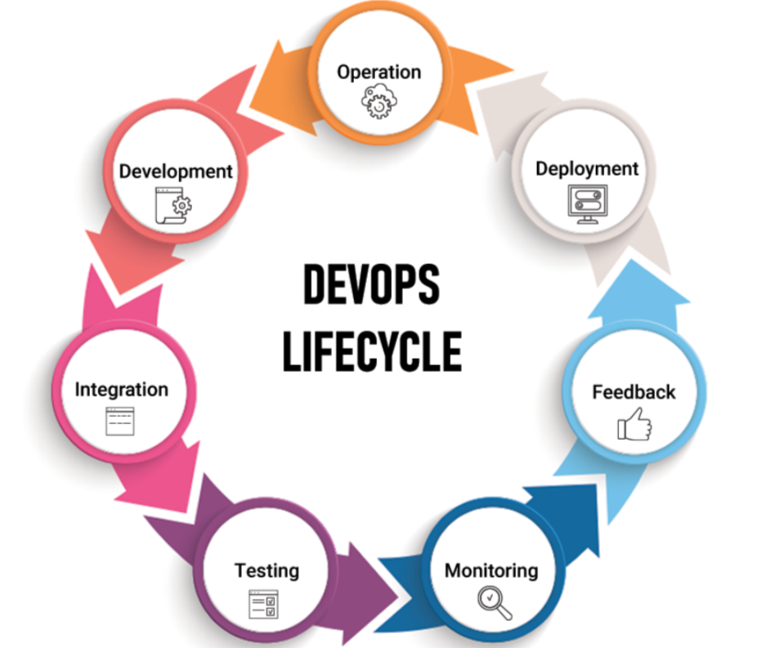```

1. **What are the benefits and challenges of DevOps?**

Benefits of DevOps:

1. **Faster Delivery:** DevOps enables faster and more frequent software delivery. This results in quicker time-to-market for new features and updates.

2. **Improved Collaboration**: DevOps fosters collaboration and communication between development, operations, and other cross-functional teams. This alignment helps in sharing knowledge, and resolving issues more effectively.

3. **Enhanced Quality**: By integrating automated testing, code reviews, and deployment pipelines, DevOps improves software quality. Continuous monitoring and feedback loops enable early detection and resolution of issues, leading to more stable and reliable applications.

4. **Increased Efficiency**: Automation of repetitive tasks, such as builds, tests, deployments, and infrastructure provisioning, reduces manual efforts and human errors. This improves efficiency and allows teams to focus on higher-value activities.

5. **Scalability**: DevOps practices and tools facilitate scalability by enabling the management of infrastructure as code (IaC), containerization, and cloud-native development. Organizations can scale resources dynamically to meet changing demands.

Challenges of DevOps:

1. **Cultural Resistance:** Adopting DevOps requires a cultural shift and collaboration among teams, which may face resistance from traditional siloed structures, hierarchical cultures, and resistance to change.

2. **Complexity**: Managing complex infrastructure, microservices architectures, and distributed systems can introduce challenges in configuration management, version control, and integration testing.

3. **Skill Gaps**: Implementing DevOps requires expertise in automation tools, cloud platforms, infrastructure as code (IaC), containerization, and continuous integration/continuous delivery (CI/CD) practices. Skill gaps among team members may hinder adoption.

4. **Security Concerns**: Rapid development and frequent deployments in DevOps can raise security concerns related to vulnerabilities, compliance, access control, and data protection. Security must be integrated into the DevOps lifecycle.

5. **Toolchain Integration**: Managing and integrating multiple tools and technologies in the DevOps toolchain (e.g., CI/CD tools, monitoring tools, configuration management tools) can be complex and require expertise in tool selection and integration.

1. **Explain a capstone project one can develop using open-source framework focused on DevOps.**

One capstone project idea that leverages open-source DevOps frameworks could be:

Title: Automated CI/CD Pipeline for Containerized Microservices Deployment

Objective: The objective of this capstone project is to design and implement an automated Continuous Integration/Continuous Delivery (CI/CD) pipeline using open-source DevOps frameworks for deploying containerized microservices applications.

Key Components and Features:

1. Containerization with Docker:

- Containerize microservices using Docker to encapsulate each service and its dependencies into lightweight, portable containers.

2. Orchestration with Kubernetes:

- Utilize Kubernetes for container orchestration, scaling, and management of microservices across a cluster of nodes.

3. Source Code Version Control:

- Use Git and GitHub/GitLab/Bitbucket for version control of microservices source code, ensuring collaboration, history tracking, and code review capabilities.

4. Automated Builds with Jenkins:

- Set up Jenkins as a CI server to automate builds, tests, and code quality checks for microservices whenever new code is pushed to the repository.

5. Automated Testing:

- Implement automated testing using frameworks like JUnit, Selenium, or Postman for unit testing, integration testing, and API testing of microservices.

6. Artifact Repository with Nexus/Artifactory:

- Use Nexus or Artifactory as an artifact repository for storing Docker images, build artifacts, and dependencies required for deployment.

7. CI/CD Pipeline Configuration:

- Configure Jenkins pipelines (Jenkinsfile) to define CI/CD workflows, including build, test, package, deploy, and release stages for microservices.

8. Deployment Strategies:

- Implement Blue/Green deployment or Canary deployment strategies using Kubernetes to ensure zero downtime and seamless updates of microservices.

9. Infrastructure as Code (IaC):

- Use tools like Terraform or Ansible for infrastructure provisioning and configuration management, defining infrastructure as code (IaC) for reproducibility and automation.

10. Monitoring and Logging:

- Integrate monitoring tools like Prometheus, Grafana, or ELK Stack for real-time monitoring, logging, and alerting of microservices performance, health, and incidents.

11. Security and Compliance:

- Implement security practices such as container security scanning, vulnerability assessment, access control, and compliance checks to ensure security and governance in the CI/CD pipeline.

Expected Deliverables:

- Automated CI/CD pipeline implemented using open-source DevOps tools and frameworks.

- Containerized microservices with Docker and Kubernetes orchestration.

- Jenkins pipelines for automated builds, tests, and deployments.

- Infrastructure provisioning scripts using Terraform/Ansible.

- Monitoring and logging dashboard for microservices monitoring.

- Documentation, user guides, and project presentation.

Benefits and Impact:

- Streamlined development and deployment processes for containerized microservices applications.

- Faster time-to-market with automated builds, tests, and deployments in the CI/CD pipeline.

- Improved code quality, reliability, and scalability of microservices through automation and orchestration.

- Enhanced visibility, monitoring, and management of microservices performance and incidents.

- Hands-on experience with open-source DevOps tools, containerization, CI/CD practices, and infrastructure automation.

This capstone project provides a practical opportunity to apply DevOps principles, containerization, CI/CD pipelines, infrastructure as code (IaC), and monitoring/logging practices using popular open-source frameworks and tools. It demonstrates proficiency in designing and implementing automated DevOps workflows for modern microservices architectures, preparing students for real-world DevOps roles in organizations.

1. **How does the DevOps lifecycle encompass continuous integration, continuous delivery, and continuous deployment stages, and what are the key tools used in each stage?**

The DevOps lifecycle encompasses continuous integration (CI), continuous delivery (CD), and continuous deployment (CD) stages, each focusing on different aspects of software development, testing, and deployment. Below, I'll explain how these stages fit into the DevOps lifecycle and highlight key tools used in each stage:

1. Continuous Integration (CI):

- Objective: Merge code changes from multiple developers into a shared repository frequently (multiple times a day) to detect integration issues early.

- Key Activities:

- Automated builds: Compile, build, and package code automatically.

- Code quality checks: Run static code analysis, unit tests, and code style checks.

- Version control integration: Manage code changes using version control systems.

- Key Tools:

- Jenkins: Popular open-source CI/CD automation server for building, testing, and deploying code.

- GitLab CI/CD: Integrated CI/CD pipelines within GitLab for automating software delivery.

- Travis CI: Cloud-based CI/CD platform for testing and deploying code hosted on GitHub repositories.

- CircleCI: CI/CD platform for automating software development workflows.

2. Continuous Delivery (CD):

- Objective: Automate the process of deploying tested code changes to staging or pre-production environments for final testing and validation.

- Key Activities:

- Automated testing: Run integration tests, acceptance tests, and user acceptance testing (UAT).

- Configuration management: Manage environment configurations and application settings.

- Artifact creation: Package and version artifacts for deployment.

- Key Tools:

- Docker: Containerization platform for creating, deploying, and managing containers.

- Kubernetes: Container orchestration platform for automating deployment, scaling, and management of containerized applications.

- Ansible: Configuration management tool for automating application deployment, provisioning, and infrastructure management.

- Puppet: Infrastructure automation tool for managing and configuring servers and applications.

3. Continuous Deployment (CD):

- Objective: Automate the deployment of code changes directly to production environments after passing all tests and approvals.

- Key Activities:

- Deployment automation: Automatically deploy artifacts to production environments.

- Canary releases: Deploy changes gradually to a subset of users for validation before full rollout.

- Rollback mechanisms: Implement automated rollback procedures in case of deployment failures.

- Key Tools:

- Spinnaker: Continuous delivery platform for managing application deployments and pipelines across multiple cloud environments.

- AWS CodePipeline: Managed CI/CD service from AWS for automating software release pipelines.

- Azure DevOps: Integrated set of DevOps services from Microsoft for planning, collaboration, and CI/CD.

- GitOps tools (e.g., Flux, Argo CD): Automate deployment and synchronization of Kubernetes manifests based on Git repositories.

Integration across CI/CD Stages:

- CI feeds into CD by triggering automated builds and tests upon code changes.

- CD includes continuous testing, configuration management, and deployment automation to prepare code changes for deployment.

- Continuous deployment automates the deployment of validated changes to production environments, ensuring a streamlined and reliable software release process.

Overall, the DevOps lifecycle integrates CI, CD, and CD stages seamlessly, leveraging automation, collaboration, and feedback loops to deliver high-quality software continuously and efficiently. The key tools mentioned above play crucial roles in enabling each stage of the DevOps lifecycle and driving automation, scalability, and reliability in software development and deployment processes.